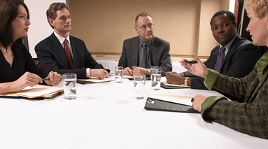








 | Facilitation Skills for  International Meetings
Creating Effective Meetings

Contents
- Thinking about Meetings 3
- Meetings & Facilitation 4
- Tasks in a Meeting 6
- Process & Relationships in Meetings 8
- Nine Must Do’s for Successful Meetings 11
- Cross Cultural Communication 13
- The Facilitator & Decision Making 15
- Setting up Meetings 17
- Model Meeting 1: A Staff Meeting 19
- Model Meeting 2: A Planning Meeting 21
- The Language of Meetings 28










1 Thinking about Meetings



- Business Meetings
Companies have meetings: Meetings of all kinds.
- Meetings are unavoidable because they are an important part of getting the work done.
- There are many different situations and purposes for meetings, however, they can be divided into two types: Successful and Unsuccessful.
Questions to consider
  - What does an unsuccessful meeting look like?
  - What does a successful meeting look like?

- Creating Successful Meetings
Since meetings are both important and unavoidable, they need to be successful all the time. The success of the company depends on it.
Where do successful meetings come from?
- Successful business meetings are created through planning, preparation, and skillful management of the meeting itself.
- A skillful facilitator can avoid potential problems and create successful meetings.

- Facilitation Skills for International Meetings
In Facilitation Skills for International Meetings, you will learn how to create successful meetings.
- It begins with a review of the process of meetings – the structure, roles, protocol, and language for successful meetings.
- This review of the basics is re-enforced by focusing on the role and skills of the facilitator.
- You will study and practice the skills in model meeting transcripts and then put the skills into use in meeting simulations.

2 Meetings & Facilitation

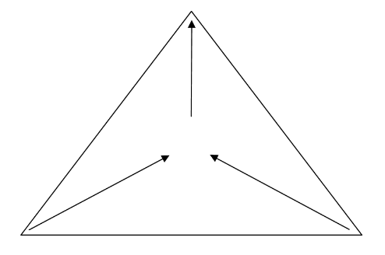

A meeting is a dynamic process.
Gathering resources towards a specific goal.

The Basics
- What is a meeting?
A meeting is a gathering of particular people, at a particular time, for a set duration, for the purpose of achieving a goal that will improve a company’s operations, products, or services in order to increase profitability.

- Facilitation: What does it mean?
Facilitation means to make a process easier and more successful.

- Chairperson Vs Facilitator– What’s the difference?
Successful meetings require a manager who can guide the step by step process of the meeting from beginning to end so the participants can achieve the purpose of the meeting.
- The meeting manager can be called the chairperson or facilitator. However, there is a difference.
- A chairperson is a participating manager. The chairperson can participate in the discussion and the decision making.
- A facilitator is a neutral manager. The facilitator does not participate in the discussion or decisions.

- A meeting: a gathering for a purpose.

- Purpose & Goal | The purpose of the meeting should be clear to all the participants so they can prepare, participate fully, and contribute to the goal.
- People | The right people need to be in the meeting. People who –  - need information  - can provide information  - can contribute to a discussion and decision.  Participants bring their knowledge, experience, and creativity to meetings.
- Time | The start time of the meeting should be clear.  The meeting should start on time.
- Duration | The ending time of the meeting should be clear.  The meeting should end on time.  - An efficient use of time in meetings makes the best use of the company’s valuable assets: Its time and its staff.
- Achievements | At the end of a meeting the participants should feel that the time has been well spent.  - The benefits of the meeting should be identifiable.  Successful meetings improve operations, make better use of all resources and improve results.  Unsuccessful meetings weaken operations and waste resources and do not improve results.  - They have no reason to exist.

3 Tasks in a Meeting

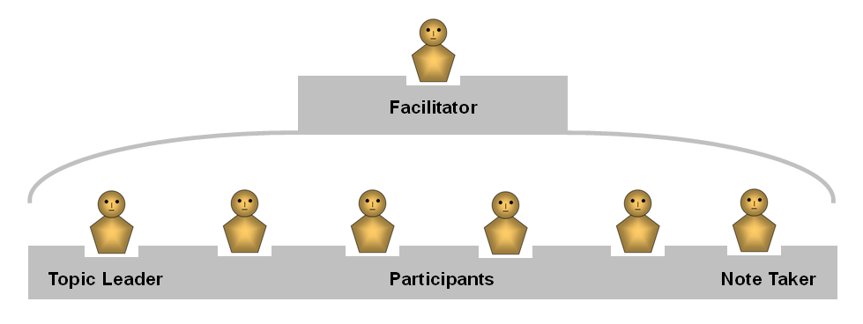

The people attending a meeting have different tasks to perform.
Meetings succeed because each person knows and completes his or her task.

- Five tasks in a meeting

1. Facilitator | Before the meeting:  - Confirms that the participants are informed of the meeting’s date and time as well as the purpose, issues, and agenda.  During the meeting:  - Manages the meeting from beginning to end.  - Encourages participants to ask questions and offer comments.  - Directs the flow of the discussion and guides it toward a conclusion.  - Makes decisions about the meeting process but does not make decisions about the issues being discussed.
2. Topic Leader | Provides information necessary for the discussion.
3. Participants | Prepare for the meeting.  Listen to the topic leader.  - Evaluate the information.  - Ask questions.  - Make comments.  - Contribute to the conclusion and decision making.
4. Note taker | Usually an assistant to the facilitator.  - Often helps to set up the meeting.  - Records the decisions during the meeting.  - Reports the decisions during the meeting.  - Prepares a report and distributes it to the participants.
5. Timekeeper | Meetings must start and finish on time.  - The timekeeper assists the facilitator by keeping track of the time and advising the facilitator.  - The facilitator can act as the timekeeper.
- Types of Meetings
Companies hold different types of meetings for different purposes: some meetings are for exchanging information, while other meetings are for making plans and decisions.
- It is essential for the facilitator and the participants to know what type of meeting they are attending.

Types of Meetings | Purpose | Goal
Staff Meetings | - Exchange information  - Update information  - Make announcements | Create cooperation by sharing information
Team Meetings | - Report & update progress of  a particular project  - Make plans | Make decisions about actions to take
Advisory Meetings | - Share ideas and suggestions with a decision maker | Inform decision maker of facts & options
Kick-off Meetings | - Start a project  - Introduce project members  - Clarify goals  - Confirm schedules & deadlines  - Confirm tasks | Confirm the project’s relevant details & focus the energy and enthusiasm of the participants
Managers’ Meetings & Board meetings | - Review reports  - Share ideas | Make decisions about policies and  actions to take

- Questions
  - What types of meetings are you involved in?
  - What is your role in the meetings?

4 Process & Relationships in a Meeting

- Process of a Meeting
An important part of the process of a meeting is its structure. In the structure of a meeting there are six stages.
- Just as a building needs a structure, a meeting needs a structure in order to succeed.
- Each stage of the meeting is important. Some stages are brief and can be done quickly while other stages take more time.

- Six Stages of a Meeting
1. Warm up
Announce the start of the meeting.
- Begin with brief social courtesies: Greet the participants and express appreciation for attending the meeting.
- Bring the participants together and create the foundation for good communication.
- This is especially important in meetings with people who do not know each other very well or if there are cultural differences.

2. Confirm the Purpose
Focus the participants’ attention on the purpose of the meeting.
- State the meeting’s purpose and goal.
- State the closing time of the meeting.
3. Clarify the Issues
Further focus the participants’ attention on the meeting.
- Review the agenda item by item.
- Identify the topic leader and time allotted for each item.
4. Deal with the Agenda
Use the agenda as the “road map” for the meeting.
- Go through the agenda item by item.
- As much as possible, keep the items separate.
- Get contributions from all the participants.
- Guide the discussion toward a conclusion.
- Do not move onto a new item without closing the previous item.
- Moving on without a clear closing wastes time.

5. Confirm the Results and Decisions
At the end of the meeting, before closing, review the results of the meeting.
- Ask the note taker to review the decisions from the notes.
- Ask the participants to confirm the decisions.
- Reviewing the decisions is important to avoid misunderstandings and to ensure action.
6. Wrap-up the Meeting
Close the meeting with brief social courtesies to maintain good relationships.
- Announce the close of the meeting.
- Refer to the next meeting if there is one: date and time.
- Acknowledge the participants’ time and contributions.

- Language of Meetings
Each stage of a meeting has its own expressions and language.
- You will find the language for meetings in the model meeting transcripts (Units 9 & 10) and in The Language of Meetings (Unit 11)

- The Agenda
The meeting has one agenda. It is road map for the discussion and decisions.
- The agenda is the list of items to be discussed in the meeting. There are usually three or more items on the agenda.
*Word Note: The “agenda” is the list. The items on the agenda are called “items”.
In Japanese the word “agenda” has a different meaning. It means the items for discussion. This is acceptable in Japanese however it is not correct in English.

- The Meeting Report
The report is essential because we cannot rely on our memories.
The report should include -
- The date, time, and duration of the meeting.
- Names of participants and their roles.
- Items on the agenda.
- Items on the agenda actually discussed.
- Decisions that are made: who, what, when.

- Process and Relationships
Two important elements in all meetings are -
- the step-by-step process of the meeting
- the relationships among the participants
The meeting process and relationships work together to make a successful meeting.
It is the facilitator’s job to balance these two elements.

- The Meeting: A Dynamic Process
A meeting is a dynamic process involving several elements.
Exercise:
Think about the five elements of a meeting below. What do you know about each one?
- Relationships
- Facilitator
- Process (Structure, agenda, and language)
- Meeting Results
- Participants & Issues

Write each of the five elements in the appropriate box.
(Check your work on page 33.)

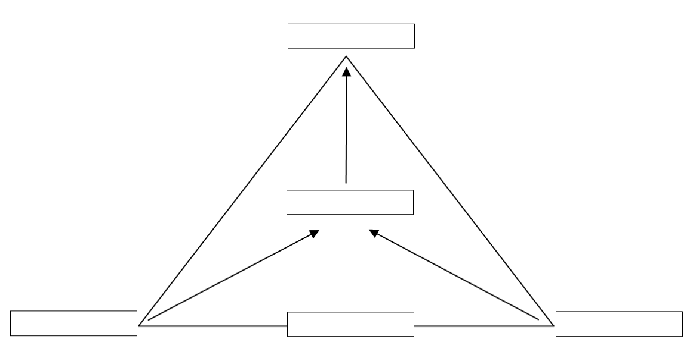

Elements of a Business Meeting

5 Nine Must Do’s for Successful Meetings

  - Common problems with meetings…
Anyone who has attended a meeting has experienced at least some of these problems.
    - Beginning discussion before all background information is presented.
    - Discussion wanders from issue to issue without focus.
    - The participants introduce ideas unrelated to the agenda.
    - Participants don’t speak because there are senior staff members in the meeting.
    - Outspoken people tend to dominate the discussion and control the decisions.
    - Quieter people tend not to express their ideas.
    - People who don’t listen repeat other people’s ideas.
    - Unprepared people talk off-issue.
    - The meeting is long and boring and ends without clear decisions.

  - … And nine ways to deal with them
The effective facilitator can avoid and overcome these common problems by following the nine must do’s for successful meetings.
      - Inform and remind the participants of the purpose of the meeting
Knowing the date, time, and place of the meeting is necessary but not enough information.
If the participants know the issues and purpose of the meeting they can prepare for and participate in the meeting.

      - Optimize the number of participants
Each meeting should have “the right number” of participants.
- Too many or too few participants will limit the success of the meeting.
- The “right number” depends on the purpose of the meeting.

      - Establish and follow an agenda
Every meeting must have an agenda. The agenda is the plan for the meeting and helps to keep the participants on track.
- The agenda includes the issues for discussion, the topic leaders, and the time allocated for each item.
- The items on the agenda should be written in order from first to last.
- Everyone in the meeting should have the agenda so they can focus on the issues.
      - State the purpose and goal of the meeting
At the beginning of the meeting clearly state the purpose and goal of the meeting, and review the agenda.
- Do not assume that the participants are thinking about or understand the purpose and goal of the meeting.
- Reviewing the purpose and agenda gets the meeting off to a good start and helps to keep it on track.

      - Involve each participant
Encourage all the participants to speak.
- Meetings can often get off balance when a few attendees do all the talking and dominate the discussion.
- These individuals naturally tend to control the decision making.

      - Use diagrams, pictures, and graphics
There is truth in the old saying, “a picture is worth a thousand words”.
- Pictures can shorten meetings and make them more effective.
- Good diagrams can shorten meeting durations by as much as 25%.
- Whenever practical, encourage participants to use diagrams, pictures, and graphics instead of handing out pages full of text.

      - Set aside important but unrelated topics
Keep the meeting on track by following the agenda.
- Do not let unrelated items enter the discussion even if they are important.
- The effective facilitator needs to protect the agenda from unrelated items: unrelated items must be set aside for a separate meeting.

      - Record & review decisions
Decisions must be written down.
- If decisions are not recorded they might not be acted on.
- Meetings need an official note taker to record decisions and review them at the close of the meeting.

      - Distribute a meeting report
Right after the meeting, prepare and distribute a brief summary of the meeting’s results and decisions to all the participants.
- The official minutes or report with all the details can be prepared later.

6 Cross Cultural Communication

  - The Challenge of Cross-Cultural Communication
- Cultural differences in the protocol of handling conflict and making decisions are barriers to successful meetings.
- The facilitator cannot ignore the differences or assume that because the meeting is taking place in a certain location everyone will automatically follow the local protocol.
- Awareness of cultural diversity and how to bring people together are essential for effective facilitators.

Conflict & Culture Quiz
What do you think about conflict?
The first step in managing conflict is to be aware of your own assumptions.
Below are some common attitudes toward conflict. Which ones reflect you?
◻ Believe conflict is bad | ◻ Believe conflict is normal.
◻ Compromise to avoid conflict | ◻ Debate the issues to win agreement
◻ Seek a quick consensus | ◻ Want the best idea to win
◻ Hold back opinions to “avoid confusion” | ◻ Speak your mind to create new ideas.
◻ Maintain the appearance of harmony | ◻ Allow an open clash of ideas
◻ Assume understanding | ◻ Insist on clear explanations
◻ Rely on unspoken agreement | ◻ State positions clearly
◻ Comply with decisions | ◻ Comply if you agree

- Protocol of Communication
- Effective communication is much more than just vocabulary and grammar.
Effective communication in any culture, in any language, depends on following the accepted rules of communication for that culture.
These rules are called the protocol of communication.
Protocol consists of -
Content What to say and do.
Timing When to say it and do it.
Style How to say it and do it.
- Protocol is a procedure that helps create good relationships. It is an expression of respect and a willingness to communicate.
Question 1: What are some examples of protocol for communication?
Question 2: What are some of the similarities and differences in protocol between Japanese and other cultures?

  - Three steps to overcoming conflict in cross-cultural meetings
If a meeting is well planned and well managed, conflict will be easier to handle.
Create a successful cross-cultural meeting in three steps.
- Acknowledge that cultural differences exist among the participants and ask everyone to cooperate in order to create a successful meeting.
- Ask for the participants’ agreement.
- Clearly explain the meeting’s protocol for discussion and decision making. (The 6 Stages on page 8)
- Ask the participants to confirm their understanding.
- Conduct the meeting strictly according to the protocol.
- Treat everyone equally and fairly.
- Equal and fair treatment will re-enforce the protocol.

7 The Facilitator & Decision Making



  - The facilitator’s role
Discussing an issue can be fairly easy; however, bringing that discussion to a conclusion can be very difficult.
The facilitator needs to be able to guide the participants toward a decision without making the decision for them.
- The true facilitator is neutral in the discussion and decision making.
- He or she has no vested interest in the outcome of the meeting.

  - Guiding a discussion toward a conclusion
The facilitator can guide the discussion in various ways:
- Begin the discussion by clearly stating the issue to be discussed.
- Keep the discussion focused on the issue.
- Set aside off-issue comments.
- Make sure that all the background information is presented before the discussion begins.
- This is a critical first step.
- Encourage discussion to find common points and points of disagreement.
- Make sure all the participants have an opportunity to speak.
- Summarize the points from the discussion.
- Group the points into common issues.
- Identify the points agreed upon.
- Identify the points of disagreement.
- When an agreeable proposal seems to appear, restate it to the participants.
- In your restatement, include all the details and ask for confirmation from all the participants.
- The note taker will record your restatement.
- If there is no clear agreement, clearly state the two positions.
- Emphasize the points of agreement and clearly state the differences.
- Ask the participants to focus on these options.
- Allow for new proposals that will overcome the deadlock.
- If no consensus appears, suggest…
- making a decision by majority vote, or
- leaving the issue undecided and scheduling a new meeting.
  - Decisions: What, Who, by When?
A decision is the conclusion following thought, and possibly discussion, about a future course of action which includes three key elements:
1. What is to be done?
2. Who is to do it?
3. When is the deadline?
If one of the elements is missing, there is no decision!

  - Coming to a decision
There are three basic ways to come to a decision in a meeting.
The facilitator must be aware of which process is required and guide the meeting accordingly.

- Consensus All the participants agree on and accept one idea.
- Consensus is achieved by all the participants expressing their own point of view.
- Discussion continues until consensus is achieved.
- Simply agreeing with the first speaker in order to avoid conflict or save time is not achieving a consensus.
- Achieving consensus takes time and it is not always easy.
- Deciding by consensus maximizes the support for the decision and assures the decision will be carried out.

- Majority The idea that most participants support is accepted as the decision.
- To establish a majority position a vote must be carried out, usually by a show of hands for and against. The facilitator must announce the number of votes for and against.
- A majority vote is one way of overcoming a deadlock when consensus cannot be achieved.
- Because there was full discussion, compliance with the decision can be expected but not guaranteed. Those who voted against the proposal may hold back their support later.

- Authority One person in authority in the meeting makes the decision.
- The authority will listen to the discussion of differing ideas and then make a decision.
- The authority can stop the discussion at any time even before all the ideas have been presented.

8 Setting up Meetings

  - Plan for success
A successful meeting begins with the preparations.
Giving the participants clear and complete information about the purpose and goal of the meeting is part of the foundation for success.
Use the following two model e-mails as templates for your own e-mail.

Model E-mail 1
Below is an e-mail to set up a staff meeting about cross cultural meeting skills.
You will find the meeting transcript (#1) in Unit 9.

Subject: | Cross Cultural Meetings / July 7
Attachment: | Culture & Conflict Quiz
Dear Mr. Benton,

As you know, Nippon Taiyo Bank is rapidly expanding its business overseas. This means that more of our meetings include staff from different cultures.

This cultural diversity is a great asset for Nippon Taiyo but we must learn how to work effectively with it.

The HR department would like the staff members to report their experiences and make suggestions on how to make our meetings better.

We would like you to attend a meeting and give a short report on your meeting experiences at Nippon Taiyo. Please focus on conflict and decision making. Please complete the attached Culture & Conflict Quiz. Your report should be about 3 minutes.

The meeting will be held on Tuesday, July 7 from 10:00 to 11:30 in meeting room 13-A. Mr. Nobu Shimizu of the HR Dept will facilitate the meeting.

If you have any questions please feel free to contact me.

Please confirm that you received this message and can attend the meeting by return e-mail.

Thank you very much.

Best regards,
Yukie Komatsu
HR Dept.

Model E-mail 2
Below is an e-mail to set up a team meeting about a proposal for a new service.
You will find the meeting transcript (#2) in Unit 9.

Subject: | Meeting Re: Micro-financing / July 15
Attachment: | Memo: Micro-financing proposal
To the members of the New Products Development Team

Dear All,

I am writing to ask you to attend a special team meeting to consider a proposal about micro-financing.

The meeting is scheduled for Thursday, July 15, from 14:30 to 15:30. I have booked meeting room 3-C.

Belinda Pradesh will be the topic leader. Please read the attached memo about the proposal.

Yuki Sato will facilitate.

Please respond by return e-mail to confirm that you have received this information and will be able to attend the meeting.

Thank you very much.

Best regards,
Mai Hoshino

9 Model Meeting 1: A Staff Meeting

  - Transcript Notes
Below is the language for the facilitator to conduct a meeting.
- The meeting includes staff from different departments so the language is somewhat formal.
- Compare this to the language in Model Meeting 2: the language is more informal because the participants work together and have regular meetings.
- Notice how the facilitator and speakers combine the courtesies and appreciations with the functional language.

  - Meeting Background
Nippon Taiyo Bank is a large international bank based in Tokyo. It has a goal of becoming a full service international corporate bank.
- As the bank expands overseas the staff has become more international. Dealing with diverse ideas and conflict in meetings has become an important issue.
- As part of its staff development program, the training department has asked the staff to report their meeting experiences and awareness of how to deal with conflict.

Shimizu Good morning, everyone.  My name is Nobu Shimizu. I am from the HR department. I’ll be facilitating today’s meeting.  Thank you all for your participation in the meeting. The HR Department appreciates your time.  Everyone is very busy so I want to finish the meeting by 11:30.  You all received the e-mail so you know that the purpose of our meeting is to discuss the cultural attitudes to dealing with conflict in meetings.  The goal of these meetings is to advise HR how to develop the staff’s meeting skills so our meetings can be more productive.  This is a very important issue. As Nippon Taiyo expands its business overseas, more of our meetings include staff from different cultures. It is very important that our meetings are efficient and productive.  Thank you for preparing your brief reports. We’ll go around the table starting on my right. Since we have people from different departments, could you please give your name and the department you are working in?  There will be time for questions and comments after each report.  Ms Komatsu will be taking notes and will prepare a report.  Are there any questions before we begin?  All No. / No questions.  Shimizu Then, let’s begin with Mr. Benton. Mr. Benton, if you please.  Benton Thank you, Mr. Shimizu.  Good morning everyone. My name is Roger Benton. I am currently working in the M&A department. …  Thank you for listening. I’ll be happy to answer your questions.  Shimizu Are there any questions for Mr. Benton? Yes, Mr. Sonoda?  .... The discussion continues until…  Shimizu I’m sorry, but that’s all the time we have for discussion. We have to move on to our next report. Thank you, Mr. Benton.  And now I’d like to ask Mr. Imai to give us his report. Mr. Imai?  … The discussion continues until…  Shimizu I’m sorry, but we will have to bring our discussion to a close.  This has been a very useful discussion. From your presentations and discussion it is clear that your recommendation to HR is to provide the staff with more training programs in cross cultural meeting skills. Ms Komatsu will prepare a report for HR with all your comments.  Thank you all for your time, your reports, and your discussion this morning. | Greetings & courtesies  Self introduction and role because participants do not all know each other.  Appreciations.  Courtesies and confirmation of the schedule.  Confirm the purpose.  Confirm the goal.  Background to reconfirm the importance of the meeting.  Agenda.  Transition to the reports with appreciations & explanation of the procedure.  Asking for confirmation.  Introducing the first speaker.  Acknowledging the facilitator.  Greetings and self introduction  Opening the discussion.  Closing the discussion and moving on to the next speaker.  Closing the meeting with courtesies and appreciations.

  - Simulation 1
Use the Model E-mail 1 and language in Meeting Transcript 1 to have a meeting simulation.
- The students will take turns facilitating a meeting simulation: every student will facilitate.
- The facilitators will follow the six stages and the protocol of meetings.
- Each student will present a short report about cross cultural meetings (about 3 minutes)
- Each report will include responses to the Cultural & Conflict Quiz.
- There will be Q&A and discussion after each report.
- Each meeting is allotted 15 to 20 minutes.

10 Model Meeting 2: A Planning Meeting

  - Meeting Background
The New Products Marketing team at Nippon Taiyo Bank is tasked with identifying, developing, and launching new financial products and services. The decision to develop a project is made by consensus within the team but the department head, Takaya Koike, gives the final approval after examining the business model. The team is meeting to discuss a proposal for a new service: micro-financing.
The team members are from five different countries:
- Yuki Sato – Japan - Facilitator
- Belinda Pradesh – India – Topic leader
- Bob Axley – U.S
- Dieter Hinkle - Germany
- Terry Lin – Hong Kong
- Mai Hoshino – Japan – Note Taker

Yuki Good afternoon, everyone. Thank you for being here. We’ll start our meeting now. … Everyone’s here except for Dieter. Does anyone know where he is?  Mai Yes, I do. He’s on the phone with a client right now. He should be here shortly.  Yuki OK. Thanks, Mai. So, we’re having this meeting to discuss micro-financing. Did you all read the memo with the e-mail?  Everyone Yes. / Yes, I did.  Terry Yes, and I don’t know why we’re getting into charity. Why don’t we let the NGOs take care of it?  Belinda This is not about charity. This is …  Yuki I’m sorry. One moment, please, everybody. I understand your concerns Terry, but before we have any discussion we need to clarify the issues. Belinda’s going to review the main points in the memo and then we can discuss the pros and cons. How much time do you need, Belinda?  Belinda About five minutes.  Yuki OK, after Belinda’s report, we’ll have a full discussion, and then decide if the idea merits development into a proposal to Mr. Koike. All agreed?  Everyone Yes. / Fine. / Agreed.  Yuki Terry | The facilitator begins with courtesies and confirms the participants  The facilitator confirms the purpose of the meeting  Terry speaks out of turn.  The facilitator cuts in to protect the procedure.  Even though Terry spoke out of turn, the facilitator said something positive about his concern. This maintains the relationship.  The facilitator confirms the goal of the meeting  The facilitator says “All agreed?” to get quick agreement or confirmation rather than using expressions such as “Is that all right with everyone?”
Terry Yes, sorry. That makes sense.  Yuki Good. Mai will be taking notes and after the meeting, she’ll prepare the report for Mr. Koike. We need to wrap up today just before three-thirty because another department has booked this room.  Dieter (Arriving late) Sorry to be late, everyone. I just got off the phone with P-B Cable.  Yuki Thanks for joining us. We’re just getting started.  Bob How are things with P-B?  Dieter Well, they want to change the terms of the contract.  Bob What? Change the terms now?  Dieter Yes, They said that…  Yuki Excuse me, Dieter. I know the P-B contract is important but we can’t discuss it now. This meeting is about micro-financing and we have to finish by 15:30. Can you set up another meeting about P-B?  Dieter Sorry. I can do that.  Yuki Thank you. So, Belinda, if you please. Could we have your report on micro-financing?  Belinda Thanks, Yuki. Good morning, everyone. First, I’d like to say that I understand Terry’s concern, too. However, I really think that micro-financing has business potential for us. Let me highlight the main ideas and then I’d like to hear your thoughts.  Every month, overseas workers all over the world remit billions of dollars to their home countries. This is a huge market that we could develop here and overseas.  The first step is to offer foreign workers in this country a special account that includes a low cost remittance service to accounts in their home countries. This would simplify the transfer for the workers and increase the number of depositors for us. It would also give us tie-ups with banks in overseas markets.  The next step would be to offer micro-financing to depositors with good track records. Their families could use the loans to develop their farms or businesses. After that we could offer micro-financing to communities for infrastructure projects such as water, sanitation, and electrification.  Even though each loan is small the volume of business at this level can be very profitable. That’s the basic idea. Do you have any questions? … Yes, Bob?  Bob This sounds interesting. How would …  Terry Yes, it’s interesting as an NGO project but I think we need to stick to our core business.  Yuki I’m sorry, Terry, but Bob was asking a question. We’ll come back to you. … Bob?  Bob Yes, as I was saying, I think this sounds like an interesting idea. How would the community loans work?  Belinda The guarantee and repayments would be syndicated among depositors from the same community. Or the community itself could negotiate the loan with one of our overseas branches.  Yuki Terry, do you have a comment?  Terry Thank you. Actually, I made my point about sticking to our core business but I’d like to ask about default risk on the loans.  Bob Actually, as a market sector, micro-financing has a very low rate of default: much lower than conventional loans.  Terry Really? I didn’t know that.  … Pause in the discussion. No one speaks.  Yuki Any comments anyone? Dieter? Do you have any questions?  Dieter Uhhm, yes… well, let’s see… Even though the default rate on micro-loans is low, there would be controls on the loans, wouldn’t there?  Belinda Oh, yes. There would be all the standard checking. As I said, this is business.  Bob And since the borrower is a local customer, it would be like a personal loan, right?  Belinda Yes, that’s right. The local depositor would pay off the loan.  Dieter That seems good.  Terry Yes, but what about the administration and language? I don’t think our branch staff can take care of all these foreign workers. | The facilitator cuts in again to protect the agenda but confirms the importance of Deiter’s concern.  Overview  Courtesy  Background  The Details  Process: Step 1  Process: Step 2  Conclusion  Terry interrupts Bob  The facilitator cuts in to protect the procedure.  The facilitator prompts questions and comments directly.
Dieter Yes, what about the language issue. It’s a serious problem.  Yuki What do you think, Belinda?  Belinda Actually, it’s a good point. I hadn’t thought about the language issue.  Dieter Hmmm …I don’t think this is going to work.  Terry Yes, it’s really outside out core business.  Yuki Let me summarize the points so far.  There seems to be general agreement that micro-financing based on local depositors has potential as a business plan. Is that right?  Everyone Yes. / Yes basically.  Yuki However, there is a language issue to deal with. So, let’s focus on how to overcome the language barrier. Does anybody have any ideas? Bob?  Bob Well, we’d need to provide language training programs for our staff.  Belinda Or we could hire more staff with the language skills.  Dieter And we could set up a central administration with online links to the branches.  Terry Why not outsource the service to overseas offices?  Yuki Those are all good ideas. It seems that language is not such a barrier after all. We are almost out of time. Are there any other issues to discuss?  Dieter Yes. I’m wondering about our computer system. It’s pretty old. Can it handle these new transactions?  Terry Probably not, but let me look into that.  Belinda Good. Thank you, Terry.  Yuki Are there any more comments or questions from anyone?  Everyone No. / Not at this time. / Not now.  Yuki So, let’s summarize the discussion. Everyone seems to agree that micro-financing is worth developing as a business model for serious consideration. Is that right?  Everyone Yes. / Yes, that’s right. / Right  Yuki Good. Mai, could you read your notes, please?  Mai Certainly. Belinda is proposing that we set up a micro-financing business unit for foreign workers based on three points: 1. local deposits, 2. a remittance service, and 3. moving into personal and then community micro-loans. Is that right?  Everyone Yes. / Yes, that’s right. / Yes, that’s the idea.  Mai Two important issues are language and the computer system.  Yuki Terry will check into the computer system, is that right?  Terry Yes, that’s right.  Mai Thank you. And Belinda will write the proposed business plan for Mr. Koike.  Yuki Thank you, Mai. Do you need some assistance, Belinda?  Bob I’d like to work with Belinda on this.  Belinda Thanks, Bob.  Yuki OK. Thank you Bob. Have you got all that, Mai?  Mai Yes, I have.  Yuki Thank you. Can we meet again next Thursday at 14:30 for a progress review?  Everyone Yes. / Yes, that’s fine.  Yuki Belinda, could you distribute your plan by Wednesday so everyone can see it before the meeting?  Belinda That’s OK with me. Is that OK with you, Bob?  Bob Yes, fine with me.  Yuki And Mai will prepare a meeting report for Mr. Koike.  Mai Yes, I’ll do it right after the meeting. I’ll show it to you later this afternoon.  Yuki Thank you, Mai. OK, everyone. Thank you all for your contributions and thank you Belinda for your interesting proposal. That finishes our meeting. Thank you again, everyone. See you next Thursday at 14:30. | The facilitator prompts a response.  The facilitator summarizes the points of agreement.  The facilitator focuses the discussion on the language problem  The facilitator summarizes the points of agreement, notes the time and moves the discussion to other concerns.  The facilitator summarizes the points of agreement and prompts agreement.  The facilitator asks for the note taker to report.  The facilitator confirms additional points.  The facilitator confirms the agreements again.  The facilitator sets up the next meeting.  The facilitator closes with courtesies and appreciations

  - Simulation 2
Use Model E-mail 2 and the language in Meeting Transcript 2 to have a meeting simulation.
- The students will take turns facilitating a meeting simulation: every student will facilitate.
- The facilitators will follow the six stages and the protocol of meetings.
- Each student will make a short presentation to make a proposal (about 3 minutes).
- The proposal should be based on the student’s own work experience.
- Prepare the presentation with the Project Proposal form.
- Using Belinda Pradesh’s presentation as a model.
- There will be Q&A and discussion after each report.
- Each meeting is allotted 15 to 20 minutes.

Creating a Proposal
Prepare a brief report on a proposal for your work.
Report length: Brief - About 3 minutes

Reporting Points | Information
What department are you in?
What is your proposal?
Operations, Service, or Product?
Background information to the proposal:
Current situation & need.

What are the benefits of the proposal?
Who will benefit? How?

11 The Language of Meetings


- Vocabulary for the Facilitator
Getting people’s attention
  - May I have your attention, please? (Formal: for a large meeting)
  - Alright, everybody. / OK, everybody (informal)
  - Sorry to interrupt but I think we should get started now.
  - I'd like to get started now.
  - I think we should start now.
  - Shall we start now?
  - Can we start now?
  - Shall we get down to business?
  - I think we should get down to business now.
  - Could we get down to business now?

Reviewing the Agenda
- Let’s take a look at the agenda.
- We have three items on the agenda this evening.
- Is there anything else for the agenda?
- Are there any other items for the agenda?
- Does anyone have anything else for the agenda?
- Does anyone want to add anything to the agenda?

Organizing the Agenda
- Let’s start with…and then
- I think we should start with… and then
- I think our first item should be…
- I’d suggest we start with … and then…
- Let’s take a break after we finish …
- Mr. Ono, about how much time do you need for your presentation?

Introducing the Speaker
- Our first / next speaker is Mr. Ono.
- Mr. Ono, would you give us your report, please?
- Mr. Ono?

Speaker’s Response to the Facilitator
- Thank you, Mr. Garrard.
- It’s my pleasure.
- My pleasure. (Informal)
- … Good evening, everyone.

Conducting the discussion
  - Thank you, Mr. Ono. We have time for some questions.
  - Are there any questions for Mr. Ono?
  - Are there any more questions for Mr. Ono?
  - Mr. Suzuki, do you have any questions for Mr. Ono?
  - What do you think about this, Mr. Suzuki?
  - Do you have any comments on this, Mr. Suzuki?

Moving to a Decision
- Mr. Ono, what do you think about this?
- What do you think about this?
- How do you feel about this?
(Note: “How do you think about…?” is not correct.)
- I’d like to get your opinion on…
- What do you think we should do?
- Do you all agree with this proposal?

Taking a Break
- It’s time for a break. We’ll begin again in 10 minutes.
- Why don’t we take a short break now? Let’s start again in 10 minutes.
- I think we should take a short break now.
- I think it’s time for a short break.
- We’ll start again at ____________.

Starting After a Break
- It’s time to start again.
- Shall we start again?
- Shall we continue?
- We’ll continue with ________________________.

Wrapping up the discussion
- We have time for one more question.
- If there are no more questions then we’ll move on to our next item.
- I’m sorry that’s all the time we have for questions.
- I’m sorry we’re all out of time.
- I’m sorry we have to bring this to a close.
- I’m sorry. This is very interesting but we have to move on to our next item / the next item on our agenda.
- Thank you everyone.
- Thank you for a very interesting presentation, Mr. Ono.
- That was a very informative report, Mr. Ono. Thank you very much.

- Questions and Discussion

Introducing Your Question
- I have a question.
- Could I ask (you) a question about…?
- Could I ask (you) about…?
- I’d like to ask (you) about...
- I have two questions. First… Thank you. And my second question is…
Note: “May I have a question?” is never correct.

Questions for Clarification
- I think you said… Is that correct?
- I think you told us that… Am I right?
- Did you say…?
- I'm sorry. You said something about… but I didn't understand it.
- Did you say something about…?

More Information
- Could you tell me more about…?
- I’d like to get more information about …
- I'm sorry. You told us about … Could you give us some more details?

Questions to Challenge and Test
- You said … Could you tell us what you mean?
- You said … Could you be more specific?
- What’s the connection between A and B?
- I’m sorry. I don’t see the connection between A and B.
- I think…. What's your opinion?
- You said… but don’t you think that...?

- Responding to Questions
Pausing to Think
If you need time to think about a response you must say something: Silence is rude.
- That's an interesting question.
- Let me see.
- Let me think about that.

Clarifying a Question
Don’t try to answer a question if you don’t understand it. Always ask for clarification.
- I’m sorry. Could you repeat your question, please?
- Could you say that again, please?
- I'm sorry. Could you rephrase your question, please?
- I'm sorry. I don't understand your question.

Responding to Questions
Avoid answering questions with just one word, “Yes” or “No”. Short blunt answers do not create an interactive atmosphere. Always expand on a simple answer.
- Yes, that's right.
- No. I think you misunderstand.
- Let me explain.
- I'd like to explain.
- I'm sorry. I don't have any more information about that.

Responding to Answers
  - I understand, thank you.
  - I see, thank you
  - I’m sorry. I’m not sure what you mean.

Giving Opinions
- I think that…
- I feel that …
- Personally, I feel / believe / think that…
- It seems to me that…

Making Proposals
- I think we should…
- Can we…?
- Could we…?
- What about this idea? ...

Agreeing
When you agree you should summarize the points of agreement and disagreement, and explain why.
- I agree with you because…
- I agree with what you are saying because…
- I agree that we should…
- I see what you mean.
- You've got a point.
- You're right about that.

Disagreeing
- I see what you mean, but I (still) can't agree with you. I think…
- I agree that something should be done, however, …
- I agree with your point that …but …
- That's true, but…
- I'm afraid I'm not entirely convinced.
- No, I don't think that's right. I think…
- I'm sorry, I don't agree because…
- I'm afraid I can't agree with you. I think…

- Vocabulary for Discussion
Interrupting a discussion
Sometimes it is necessary to join a conversation that you have been listening to. Be careful not to interrupt while someone is speaking. Wait until there is a pause in the conversation and then say…
- Excuse me. May I say something?
- I’m sorry, may I interrupt?
- Sorry to interrupt you but …
- I'd just like to say that…
- I’d like to add something.
- Could I add something?

Accepting an Interruption
- Yes?
- Certainly, go ahead.

Rejecting an interruption
- I'm sorry, could I finish first? Then I'll answer your question.
- Could we discuss that after I finish?
- Could we take that up later?
- I’m sorry, I’d like to just finish what I saying.

The meeting: A dynamic process from page 10.
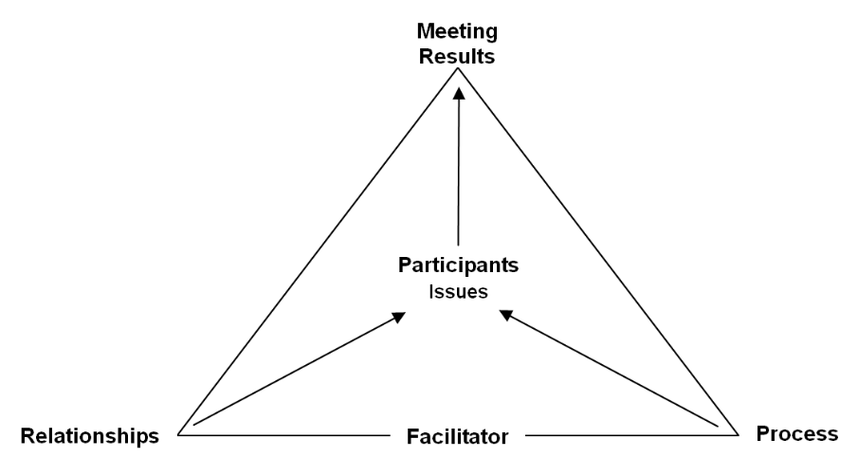
Participants
& Issues



Facilitation Skills for International Meetings
Kenneth Goldstone
with the editorial assistance of
Ben Allan and Eriko Suzuki

August 2010
Revised September 2010 & March 2011

This Edition October 2014



Tokyo, Japan

